**Capstone Project - Battle of the Neighborhoods**

1. Introduction: Business Problem - Opening a Japanese Restaurant

New York City's demographics show that it is a large and ethnically diverse metropolis. With it's diverse culture , comes diverse food items. There are many restaurants in New York City, each belonging to different categories like Chinese , Spanish , French etc.

If you're a stakeholder, entrepreneur, or chef interested in opening a Japanese restaurant in New York city, this will be for you.

Using efficient data science tools, we will suggest the promising locations to solve the below problems of finding out

* Which areas in New York City have Japanese restaurants?
* Which all areas lack Japanese Restaurants?
* Which is the best location for Japanese restaurants in New York City?

1. Data Description

For this project we need the following data:

(1) New York City data that contains list Boroughs, Neighborhoods along with their latitude and longitude.

* + - Data source : https://cocl.us/new_york_dataset
    - Description : This data set contains the required information. And we will use this data set to explore various neighborhoods of New York City.

(2) Japanese restaurants in each neighborhood of New York City.

* + - Data source : Fousquare API
    - Description : By using this API, we will get all the venues in each neighborhood. We can filter these venues to get only Japanese restaurants.

(3) GeoSpace data

* + - Data source : https://data.cityofnewyork.us/City-Government/Borough-Boundaries/tqmj-j8zm
    - Description : By using this geo space data we will get the New York Borough boundaries that will help us visualize choropleth map.

1. Methodology

(1) Collect the New York City data from https://cocl.us/new_york_dataset.

(2) Find all venues for each neighborhood using FourSquare API.

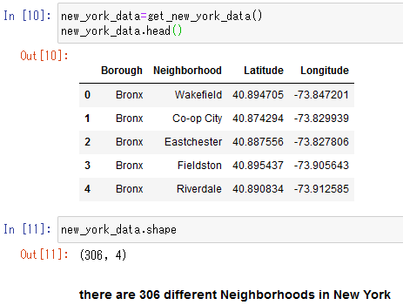

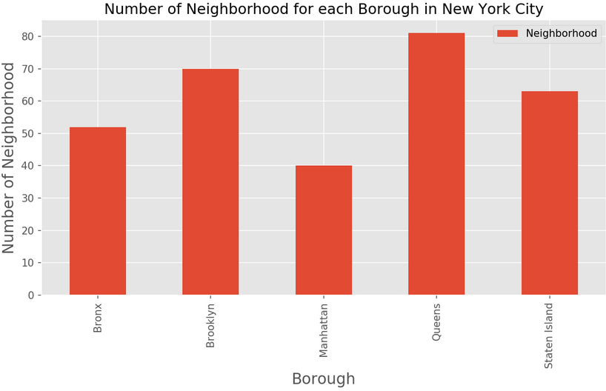

(3) Filter out all venues that are Japanese Restaurants for further analysis.

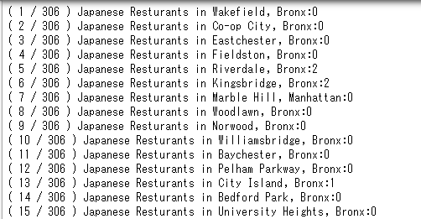

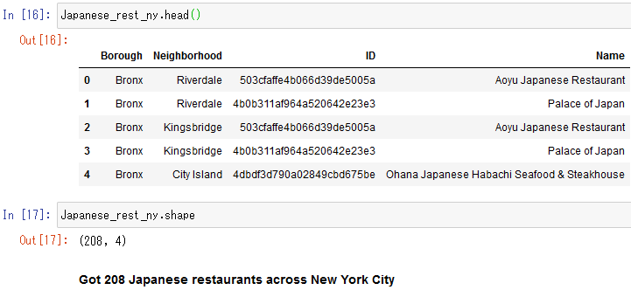

(4) Find the Ratings, Tips and number of Likes for all the Japanese Restaurants using FourSquare API.

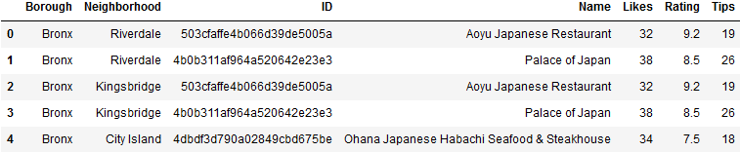

(5) Sort neighborhoods and borough the data keeping ratings as the constraint.

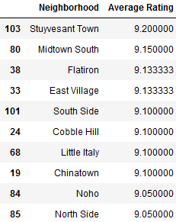

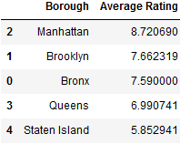

(6) Consider all the neighborhoods with average rating greater or equal to visualize on map

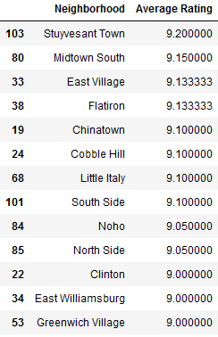

(7) Join this dataset to original New York data to get longitude and latidude.

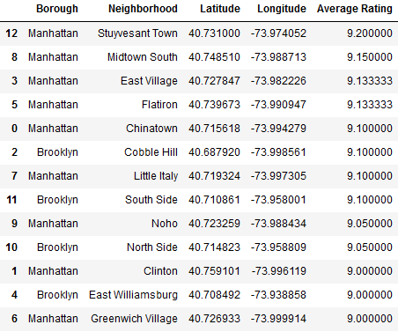

(8) Visualize the neighborhoods based on average rating by using python's Folium library.

Neighborhoods based on average rating:

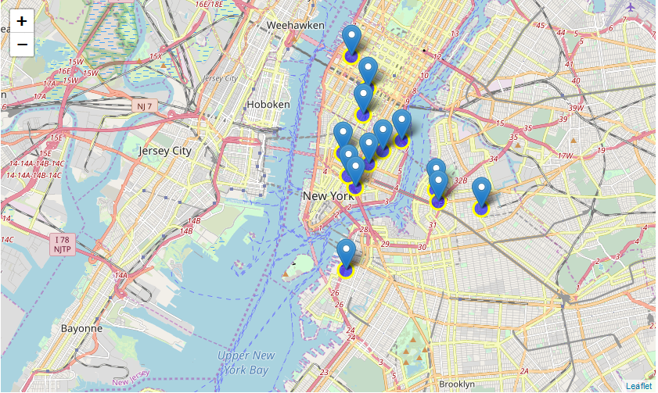

1. Results & Discussion

* There are total of 306 different Neighborhoods in New York
* We have 208 Japanese Restaurants across New York City
* Stuyvesant has the highest average rating = 9.2 for Japanese Restaurants among all neighborhoods
* Top 3 Boroughs with top average ranking of Japanese Restaurants are: Manhattan (8.72), Brooklyn (7.66) and Bronx (7.59)
* The recommendation location to open Japanese Restaurant is Stuyvesant Town based on the best-rated Japanese Restaurant in New York.

1. Conclusion

According to the above results and discussion, these are all neighborhoods option to open the first Japanese Restaurant.

